CRUISE REPORT

2012 Cruise in the Gulf of Maine to study ocean acidification and its impact on the planktonic copepod, Calanus finmarchicus

Project:
CH0712: Gulf of Maine Zooplankton and Ocean Acidification Cruise
Award: OCE-1041081.

Originating PI name and contact information:
Jeffrey Runge
School of Marine Sciences, University of Maine
Gulf of Maine Research Institute
350 Commercial Street
Portland, ME 04104
jeffrey.runge@maine.edu
207-228-1652

Contact For Data Inquiries:
Cameron Thompson
School of Marine Sciences, University of Maine
Gulf of Maine Research Institute
350 Commercial Street
Portland, ME 04101
cthompson@gmri.org

Location: Gulf of Maine
Stations were located along 3 transects (Fig. 1): 100 line extending out from Portsmouth through Wilkinson Basin; 200 line extending from Jordan Basin to Mount Desert Island; 300 line following the Maine coast from western Penobscot Bay to the Casco Bay

Start and End dates: September 24- October 3, 2012

Description:

The Gulf of Maine (GoM) is a relatively shallow inland sea punctuated by three major basins where depths exceed 200 meters. These basins provide a refuge for overwintering stages of the planktonic copepod, Calanus finmarchicus. Despite its residence at the southern edge of its subarctic range, the species is a prominent component of the zooplankton assemblage in the GoM. As the prominent lipid and energy rich prey for primary fish consumers, C. finmarchicus has high functional importance in the GoM ecosystem. Changes in its abundance due to warming waters and ocean acidification are predicted to have far reaching ecosystem impacts.

The objective of the cruise was to measure the cross-shelf differences in abundance and distribution of zooplankton, with a focus on Calanus finmarchicus. Additional shipboard experiments on Calanus copepodid and adult stages measured vital rates, particularly molting and egg production rates. Another objective was to measure the vertical and horizontal distribution of carbonate system concentrations and pH.

Sampling during the cruise concentrated on Wilkinson Basin in the western Gulf of Maine on a transect line starting in Portsmouth and continuing across Wilkinson Basin to its eastern edge. Another line sampled in Jordan Basin in the eastern half of the GoM, finishing in near shore waters adjacent to Mount Desert Island. The cruise then sampled the mid-coast region, following the typical path of the Western Maine Coastal Current back to the Casco Bay and Portland. Coincidentally the cruise dates in early autumn of 2012 followed a period of record warming in the Gulf of Maine.

Protocols:
Sampling for hydrographic and biological variables followed Canadian AZMP protocols (Mitchell et al. 2002) as a guideline. At each station one or two CTD casts were made, and Niskin bottles on a rosette were used to capture water samples at depth. Water was filtered immediately on the vessel through glass fiber filters (GF/F) and polycarbonate membrane filters with pore sizes of 5µm and 20µm. Following Strickland and Parsons (1972) the filters were processed for chlorophyll a and phaeopigment concentrations. Additional water samples for particulate organic carbon (POC) were collected from the rosette at some stations.

Several different tows were performed to sample zooplankton. At all stations, three vertical ring net (0.75 m diameter, 200-μm mesh) tows (two preserved in formaldehyde, one in 90% ethanol) were taken from near bottom to the surface. Tows for live zooplankton were taken with a 1m, 150-µm mesh ring net at selected stations. Samples from the live tow were sorted for observations of Calanus finmarchicus molting rate and egg production in the ship's laboratory and for measurement of C. finmarchicus Stage CV lipid sac volume and dry weight. In addition, replicate day-night ¼ m MOCNESS tows were carried out at selected stations. Nominal depth intervals were (in meters): bottom-175, 175-150, 150-125, 125-75, 75-50, 50-25, 25-surface. Because of mechanical difficulties with the underwater unit of the MOCNESS, the net angle was not recorded, making accurate abundance calculations unreliable. The samples were therefore archived but have not been enumerated.

The vertical net samples fixed in formalin were further processed for identification and enumeration of species. The focus was on the planktonic copepod, Calanus finmarchicus, thus there are more samples processed for Calanus finmarchicus and their development stages were enumerated. Samples would be diluted in seawater and subsamples were taken until 200 copepods and at least 75 Calanus were identified.

Mitchell, M. R., G. Harrison, K. Pauley, A. Gagné, G. Maillet, and P. Strain. (2002) Atlantic Zonal Monitoring Program Sampling Protocol. Canadian Technical Report of Hydrography and Ocean Sciences 223.

Strickland, J.D.H., and T.R. Parsons, (1972). A Practical Handbook of Seawater Analysis, second ed. Bulletin of Fisheries Research Board, 167: 201–203.

Map of the Gulf of Maine showing station locations
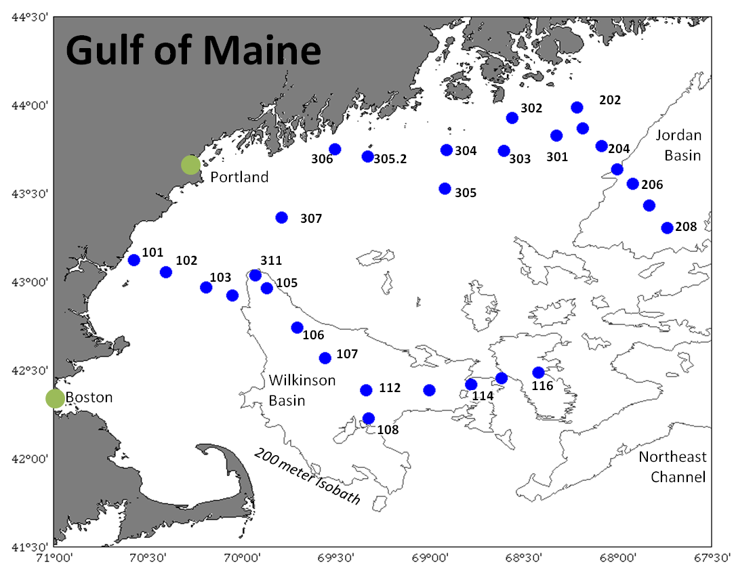

Figure 1. Location of stations in Wilkinson Basin, Jordan Basin, and along the Maine coastal zone. See Table 1 for station location and date sampled.

Table 1. Stations sampled on cruise CH0712 in chronological order. Date and location are at the start of the first CTD/Rosette cast at the site, except for Station 107 where location and time data are for the first sampling event. All times in this report are in the local time zone (EDT, which is -5 UT). Units of time represent the hours of the day (as two digits) before the colon and the minutes (as two digits) after the colon. Data not collected or faulty data are indicated by a value of -999.
 | Station | Month | Day | Time | Latitude | Longitude | Bottom-Depth
 | Number | Number | Number | HH:MM | Degrees N | Degrees W | Meters
 | 307 | 9 | 25 | 13:40 | 43.3598 | 69.7858 | 160
 | 105 | 9 | 26 | 14:04 | 42.9593 | 69.8576 | 124
 | 106 | 9 | 26 | 19:45 | 42.7667 | 69.6833 | 270
 | 311 | 9 | 27 | 00:53 | 43.0330 | 69.9190 | 200
 | 101 | 9 | 27 | 14:30 | 43.1193 | 70.5700 | 15
 | 102 | 9 | 27 | 16:03 | 43.0509 | 70.3994 | 97
 | 103 | 9 | 27 | 18:31 | 42.9673 | 70.1838 | 150
 | 104 | 9 | 27 | 21:47 | 42.9183 | 70.0482 | 95
 | 107 | 9 | 28 | 00:24 | 42.9530 | 69.8688 | 225
 | 108 | 9 | 28 | 06:55 | 42.2263 | 69.3209 | 213
 | 112 | 9 | 28 | 09:59 | 42.3823 | 69.3325 | 250
 | 113 | 9 | 28 | 17:38 | 42.3830 | 68.9830 | 200
 | 114 | 9 | 29 | 00:23 | 42.4166 | 68.7842 | 200
 | 115 | 9 | 29 | 05:38 | 42.4531 | 68.6117 | 186
 | 116 | 9 | 29 | 08:13 | 42.4805 | 68.413 | 216
 | 208 | 9 | 29 | 20:20 | 43.3027 | 67.7187 | 264
 | 207 | 9 | 30 | 04:01 | 43.4330 | 67.8232 | 236
 | 206 | 9 | 30 | 07:40 | 43.5505 | 67.9171 | 240
 | 205 | 9 | 30 | 12:52 | 43.6318 | 68.0028 | 195
 | 204 | 9 | 30 | 16:10 | 43.7667 | 68.0831 | 198
 | 203 | 9 | 30 | 18:32 | 43.8661 | 68.1830 | 170
 | 202 | 9 | 30 | 20:34 | 43.9830 | 68.2150 | 105
 | 301 | 9 | 30 | 23:24 | 43.8252 | 68.3202 | 141
 | 302 | 10 | 1 | 04:12 | 43.9229 | 68.5562 | 80
 | 303 | 10 | 1 | 06:41 | 43.7368 | 68.6016 | -999
 | 304 | 10 | 1 | 10:03 | 43.7413 | 68.9065 | 63
 | 305 | 10 | 1 | 19:36 | 43.5228 | 68.9171 | 130
 | 305.2 | 10 | 1 | 23:07 | 43.7070 | 69.3280 | 97
 | 306 | 10 | 2 | 06:50 | 43.7451 | 69.5013 | 99

Data collected:
See attached ‘CH0712_sample_log.xlsx’ for a list of the activities performed and samples collected at each station. And see attached 'CH0712_Event.xls' for a table listing the dates and times of all activities.

Reporting of cruise results
The main biological results from the cruise are reported in a research article:

Runge, J.A., R. Ji, C. Thompson, N. Record, C. Chen, D. Vandemark, J. Salisbury and F. Maps. In Press. Persistence of Calanus finmarchicus in the western Gulf of Maine during recent extreme warming. J. Plankton Res. First published online November 10, 2014. doi:10.1093/plankt/fbu098

