Cruise Report
Bivalve Larvae TRANSPORT Mapping Survey

Cruise: BT-10-01

Date: May 7, 2010

Vessel: R/V Terrapin

Area of Operations: Choptank River

Scientific Personnel: Tom Wazniak (Captain), Elizabeth North (Chief Sci), Jake Goodwin

Weather: Fair, calm and warm. Wind picked up to ~ 5 mph in the afternoon.

Objectives:
The objectives of this cruise were to 1) determine the physical and biological conditions that cue oyster (Crassostrea virginica) spawning in the Choptank River, and 2) map the distribution of multiple species of bivalve larvae along the salinity gradient and at different depths in the water column. In addition, a major objective of this first cruise is to test collection equipment and gear set up.

Activities:
All 15 stations were occupied and samples were successfully collected (Fig. 1, Table 1). Some station locations were shifted from the initial locations to expedite the cruise and to move closer to Maryland Department of Natural Resources oyster monitoring stations and Chesapeake Bay Program water quality monitoring stations. The final list of station numbers, names and locations for the TRANSPORT program can be found in Table 2.

Overall, 15 CTD casts were made, 30 plankton samples were collected, 8 water samples for chl-a pigment and TSS were collected and delivered to Analytical Services. Stations were sampled from the mouth of the river to upstream locations.

A CTD cast was made at each station, and the downcast was used to measure water properties. The CTD equipped with a fluorometer, OBS, dissolved oxygen and PAR sensors. Using a hose attached to the CTD frame, bivalve larvae were collected from near bottom to the surface by moving the CTD up through the water column in 0.5 m depth intervals at regularly spaced time intervals (e.g., every 20 s or every 60 s) depending upon the depth of the station. We estimated that our pump apparatus (50 feet of hose, an in-line flowmeter, and pump Fig. 2) was pumping ~200 L of water in 8 minutes. The water was pumped into a 55-gallon drum half filled with water (to minimize damage to the samples) and through a 64 μm mesh net to collect bivalve larvae. Samples were concentrated and washed with seawater into jars containing formaldehyde. Solution was thought to be 4% but where actually only .04%. Additional formaldehyde was added to the samples the day after the cruise so that samples were ultimately preserved in 4% formaldehyde with sodium borate buffer.

Water samples were collected for chl-a pigment (using a syringe/filter apparatus) to calibrate the fluorometer and for total suspended solids (using a water bottle provided by Analytical Services) to calibrate the OBS.

Summary:
This “shake down” cruise was highly successful. The new equipment worked well and all planned samples were collected.

Fig. 1. Sampling locations (TRANSPORT stations) in the Choptank River specific to the BT-10-01 cruise.
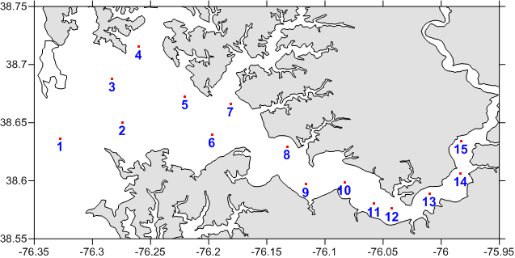

Table 1. The decimal latitude and longitude coordinates of each site, specific to cruise BT-10-01.

Table 2. BT-10-01 Consecutive Station Log.

Table 3. Station numbers, names and locations for the TRANSPORT program.

station | Latitude | Longitude | Decimal Lat | Decimal Lon | Location
01 | 38º 38' 10" N | 076º 19' 38" W | 38.6361 | -76.3273 | Choptank Mouth
02 | 38º 39' 00" N | 076º 16' 29" W | 38.6501 | -76.2747 | near buoy R12
03 | 38º 41' 15" N | 076º 16' 57" W | 38.6876 | -76.2826 | near Tilghman
04 | 38º 42' 54" N | 076º 15' 38" W | 38.7149 | -76.2604 | Broad Creek
05 | 38º 40' 25" N | 076º 13' 03" W | 38.6736 | -76.2176 | Benoni Pt
06 | 38º 38' 24" N | 076º 11' 51" W | 38.6400 | -76.1974 | Castle Haven Pt
07 | 38º 40' 04" N | 076º 10' 59" W | 38.6679 | -76.1830 | Bachelor Pt
08 | 38º 37' 47" N | 076º 07' 58" W | 38.6297 | -76.1328 | Martin Pt
09 | 38º 35' 38" N | 076º 06' 44" W | 38.5938 | -76.1121 | Jenkins Creek
10 | 38º 35' 57" N | 076º 05' 02" W | 38.5991 | -76.0838 | Hambrooks Bar
11 | 38º 34' 48" N | 076º 03' 29" W | 38.5801 | -76.0580 | Choptank Bridge
12 | 38º 34' 34" N | 076º 02' 33" W | 38.5761 | -76.0424 | Bolingbroke Sands
13 | 38º 35' 18" N | 076º 00' 37" W | 38.5884 | -76.0102 | Oystershell Pt
14 | 38º 36' 20" N | 075º 58' 59" W | 38.6057 | -75.9831 | Jamaica Pt
15 | 38º 38' 12" N | 075º 58' 45" W | 38.6367 | -75.9791 | Cabin Creek

Table 4.

