**Cruise Report**

**Bivalve Larvae TRANSPORT Mapping Survey**

***Cruise***: BT-10-09

***Date***: July 2nd, 2010

***Vessel***: *R/V Terrapin*

***Area of Operations***: Choptank River

***Scientific Personnel***: Jake Goodwin (Captain), Elizabeth North (Chief Sci), Adam Hardy, Phillip Conner

***Weather***: Hot, winds 5-10 knts SW (high 95).

***Objectives***:

The objectives of this cruise were to 1) determine the physical and biological conditions that cue oyster (*Crassostrea virginica*) spawning in the Choptank River, and 2) map the distribution of multiple species of bivalve larvae along the salinity gradient and at different depths in the water column. In addition, Phillip Conner, a contributor to HPL, was brought on board to learn about our sampling methods.

***Activities***:

16 stations were occupied where samples were successfully collected (Fig. 1, Table 1). A list of station numbers, names and locations for the Transport program can be found in Table 2.

Overall, 16 CTD casts were made, 30 plankton samples were collected, and 8 water samples for chl-a pigment and TSS were collected and delivered to Analytical Services. Stations were sampled from the mouth of the river to upstream locations.

A CTD cast was made at each station, and the downcast was used to measure water properties. The CTD equipped with a fluorometer, OBS, dissolved oxygen and PAR sensors. Using hoses attached to the CTD frame, bivalve larvae were collected from near bottom to the surface by moving the CTD up through the water column in 0.5 m depth intervals at regularly spaced time intervals (e.g., every 20 s or every 60 s) depending upon the depth of the station. We estimated that our pumps (50 feet of hose, an in-line flow meter) was pumping at 11 gallons per minute (although only 8 gallons per minute at the last two stations). The water was pumped into a 55-gallon drum half filled with water (to minimize damage to the samples) and through a 64 μm mesh net to collect bivalve larvae. Samples were concentrated and washed with seawater into jars containing 4% buffered formaldehyde.

Water samples were collected for chl-a pigment (using a syringe/filter apparatus) to calibrate the fluorometer and for total suspended solids (using a water bottle provided by Analytical Services) to calibrate the OBS (Table 3).

***Summary***:

Cruise BT1009 was successful. We were able to sample all stations in a reasonable amount of time. Two pycnoclines were present and 4 oblique samples were taken.

Fig. 1 Sampling locations (TRANSPORT stations) in the Choptank River specific to cruise BT-10-09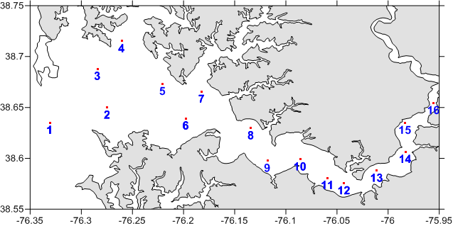

Table 1. The decimal latitude and longitude coordinates of each site, specific to cruise BT-10-09.



Table 2. BT-10-09 Consecutive Station Log



Table 3. Station numbers, names and locations for the TRANSPORT program.



Table 4. Water Sample Logs BT-10-09



Stations 2,4,6,8,11,13,15 sent to AS and for pH Bot=Bottom Top=Surface