**Cruise Report**

**Bivalve Larvae TRANSPORT Mapping Survey**

***Cruise***: BT-10-20

***Date***: September 15th, 2010

***Vessel***: *R/V Terrapin*

***Area of Operations***: Choptank River

***Scientific Personnel***: Tom Wazniak (Captain) Jake Goodwin (Chief Sci), AJ Schlenger

***Weather***: Sunny, Clear sky

***Objectives***:

The objectives of this cruise were to 1) determine the physical and biological conditions that cue oyster (*Crassostrea virginica*) spawning in the Choptank River, and 2) map the distribution of multiple species of bivalve larvae along the salinity gradient and at different depths in the water column.

***Activities***:

16 stations were occupied where samples were successfully collected (Fig. 1, Table 1). A list of station numbers, names and locations for the Transport program can be found in Table 2.

Overall, 16 CTD casts were made, 30 plankton samples were collected, and 7 water samples for chl-a pigment and TSS were collected and delivered to Analytical Services. Stations were sampled from the mouth of the river to upstream locations.

A CTD cast was made at each station, and the downcast was used to measure water properties. The CTD equipped with a fluorometer, OBS, dissolved oxygen and PAR sensors. Using hoses attached to the CTD frame, bivalve larvae were collected from near bottom to the surface by moving the CTD up through the water column in 0.5 m depth intervals at regularly spaced time intervals (e.g., every 20 s or every 60 s) depending upon the depth of the station. We estimated that our pumps (50 feet of hose, an in-line flow meter) was pumping at 11 gallons per minute (although only 8 gallons per minute at the last two stations). The water was pumped into a 55-gallon drum half filled with water (to minimize damage to the samples) and through a 64 μm mesh net to collect bivalve larvae. Samples were concentrated and washed with seawater into jars containing 4% buffered formaldehyde.

Water samples were collected for chl-a pigment (using a syringe/filter apparatus) to calibrate the fluorometer and for total suspended solids (using a water bottle provided by Analytical Services) to calibrate the OBS (Table 3).

***Summary***:

Cruise BT1020 was successful. Pump 2 had problems initially b/c although it continued to pump water the display was blank. There were no pycnoclines observed.

Fig. 1 Sampling locations (TRANSPORT stations) in the Choptank River specific to cruise BT-10-20.

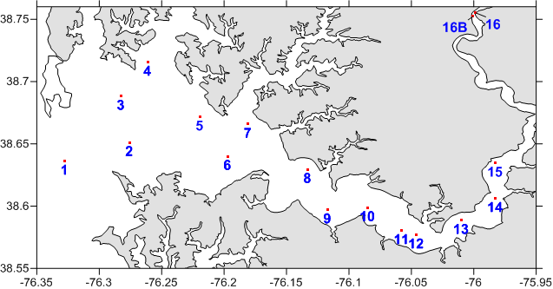

Table 1. The decimal latitude and longitude coordinates of each site, specific to cruise BT-10-20.



Table 2.

TRANSPORT Consecutive Station Log: BT10-10-20



Table 3. Station numbers, names and locations for the TRANSPORT program.

|  |  |  |  |  |  |
| --- | --- | --- | --- | --- | --- |
| **station** | **Latitude** | **Longitude** | **Decimal Lat** | **Decimal Lon** | **Location** |
| 01 | 38º 38' 10" N | 076º 19' 38" W | 38.6361 | -76.3273 | Choptank Mouth |
| 02 | 38º 39' 00" N | 076º 16' 29" W | 38.6501 | -76.2747 | near buoy R12 |
| 03 | 38º 41' 15" N | 076º 16' 57" W | 38.6876 | -76.2826 | near Tilghman |
| 04 | 38º 42' 54" N | 076º 15' 38" W | 38.7149 | -76.2604 | Broad Creek |
| 05 | 38º 40' 25" N | 076º 13' 03" W | 38.6736 | -76.2176 | Benoni Pt |
| 06 | 38º 38' 24" N | 076º 11' 51" W | 38.6400 | -76.1974 | Castle Haven Pt |
| 07 | 38º 40' 04" N | 076º 10' 59" W | 38.6679 | -76.1830 | Bachelor Pt |
| 08 | 38º 37' 47" N | 076º 07' 58" W | 38.6297 | -76.1328 | Martin Pt |
| 09 | 38º 35' 38" N | 076º 06' 44" W | 38.5938 | -76.1121 | Jenkins Creek |
| 10 | 38º 35' 57" N | 076º 05' 02" W | 38.5991 | -76.0838 | Hambrooks Bar |
| 11 | 38º 34' 48" N | 076º 03' 29" W | 38.5801 | -76.0580 | Choptank Bridge |
| 12 | 38º 34' 34" N | 076º 02' 33" W | 38.5761 | -76.0424 | Bolingbroke Sands |
| 13 | 38º 35' 18" N | 076º 00' 37" W | 38.5884 | -76.0102 | Oystershell Pt |
| 14 | 38º 36' 20" N | 075º 58' 59" W | 38.6057 | -75.9831 | Jamaica Pt |
| 15 | 38º 38' 12" N | 075º 58' 45" W | 38.6367 | -75.9791 | Cabin Creek |

Station 16 variable and chosen based on salinity < 5.5

Table 4.

BT10-20 Water Sample Log



Stations 2,4,6,8,10, 11,15 sent to AS and for pH Bot=Bottom Top=Surface